REPORT
FANTASTIC FOUR
7 APRIL 2019
On 5/4/2019, a memorable event fantastic four was organized in our college by ignite team. Many students participated in it.
The fantastic four was divided into three stages of games namely Aptitude test, Othello and bomb diffusal. The total numbers of participants were 40. From aptitude top 10 teams were selected for the next round which was Othello. And from Othello top 5 teams were selected in the final round which was bomb diffusal. After that 2 teams were declared as the winner.
APTITUDE TEST
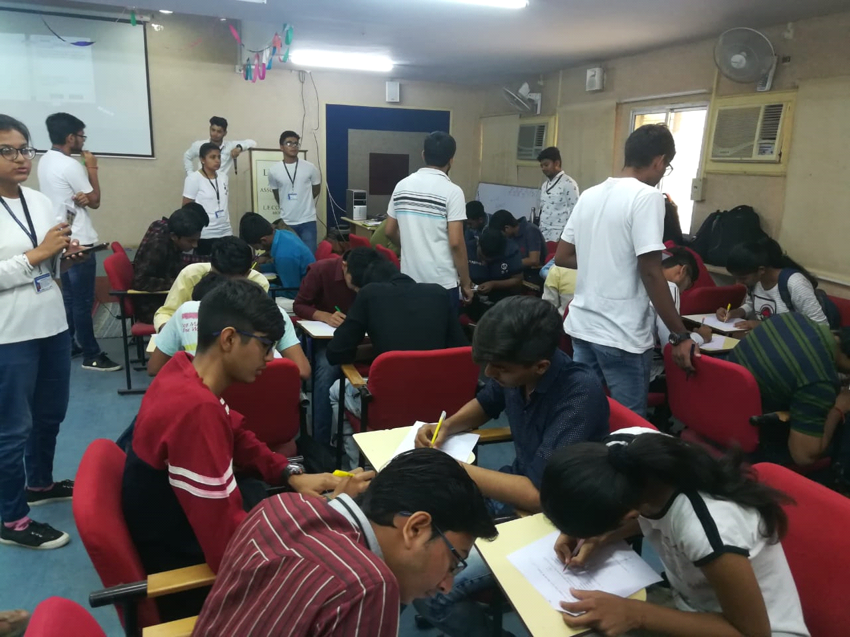
OTHELLO
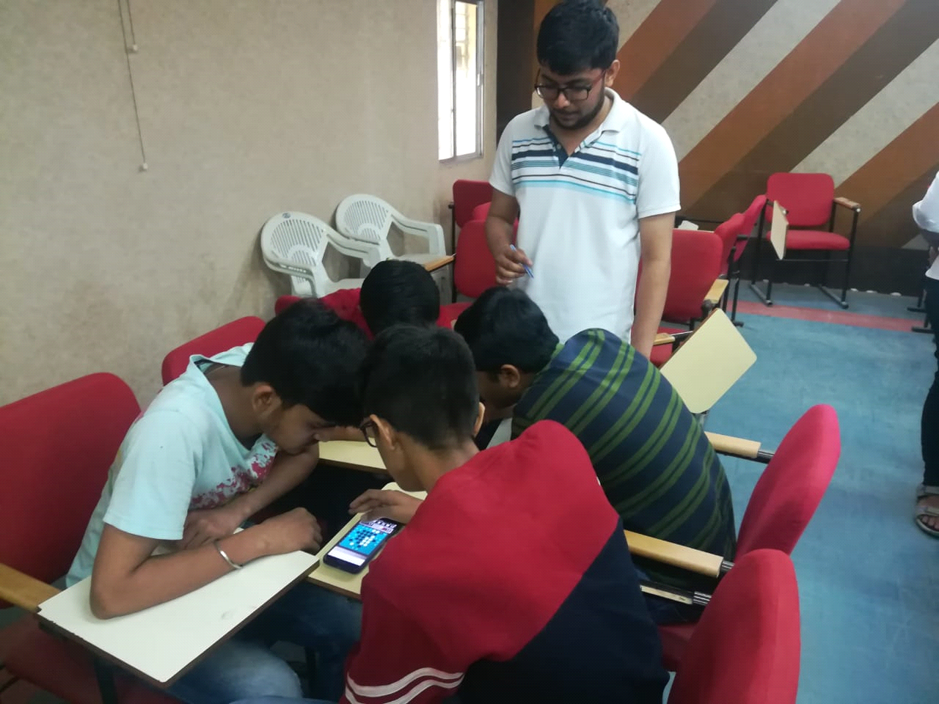
BOMB DIFFUSAL
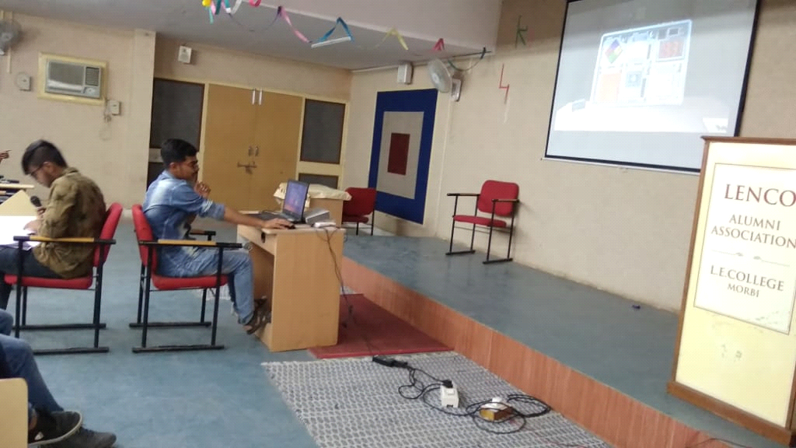

Everyone really enjoyed a lot and dispersed with a sincere hope that such mega events should be organized time and again giving the students a chance to display their talent.

